Ladi Bamgbose

Professor Forouraghi

Artificial Intelligence

25 February 2024

Technical Report

In this assignment we will be evaluating A* and Greedy Best-First search algorithms. We will evaluate the effects of alterings our base equation f(n) + g(n) + h(n) and assigning different weights to our actual cost and our heuristic.

**Problem 1**

In this problem we will identify A* and Greedy Best-First Search side by side

to see how they differ; below i will display A* on the left and Greedy Best-First

on the right:

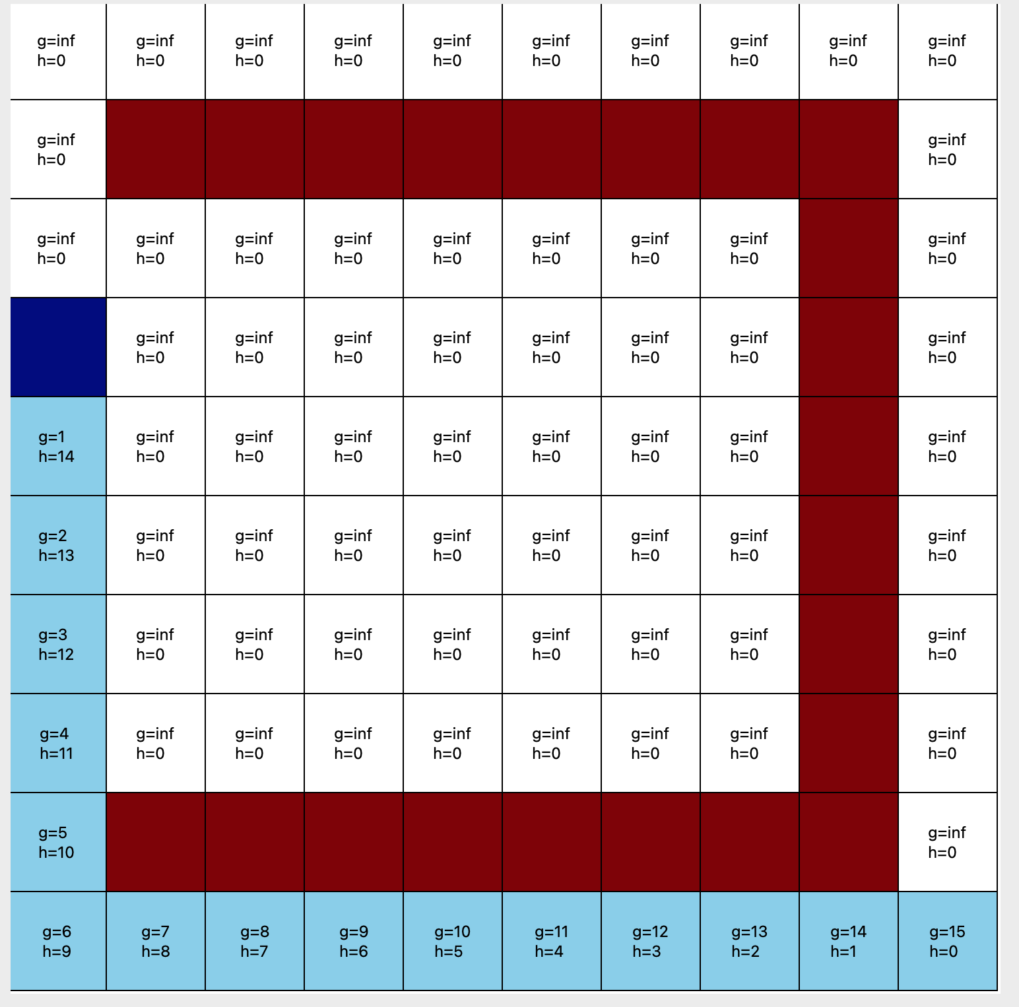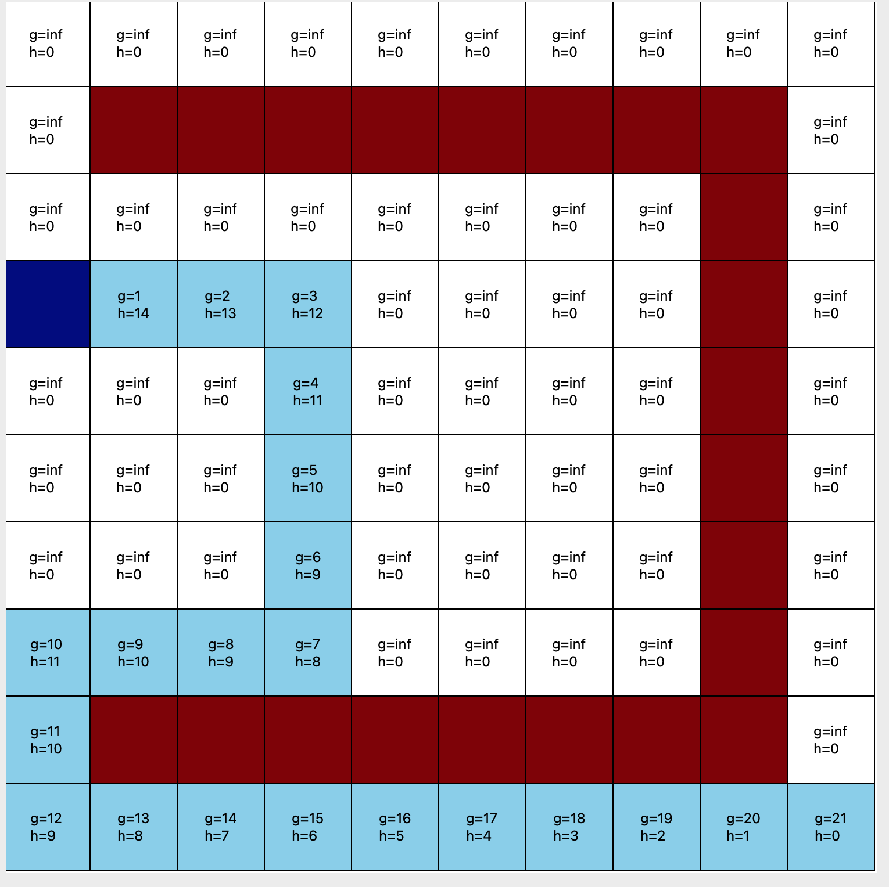

A* takes into account the actual cost so we have an algorithm that is defined as:

f(n) = g(n) + h(n), and Greedy Best-First Search only takes into account the

Heuristic, so this is defined as f(n) = h(n)

**Problem 2**

In this problem we will identify the effects of changing our heuristic calculation from

Manhattan to Euclidean. Euclidean calculation is defined as (y2 - y1)^2 + (x2 -x1)^2

Below I will display the effects it has on A*(on the left) and Greedy(on the right):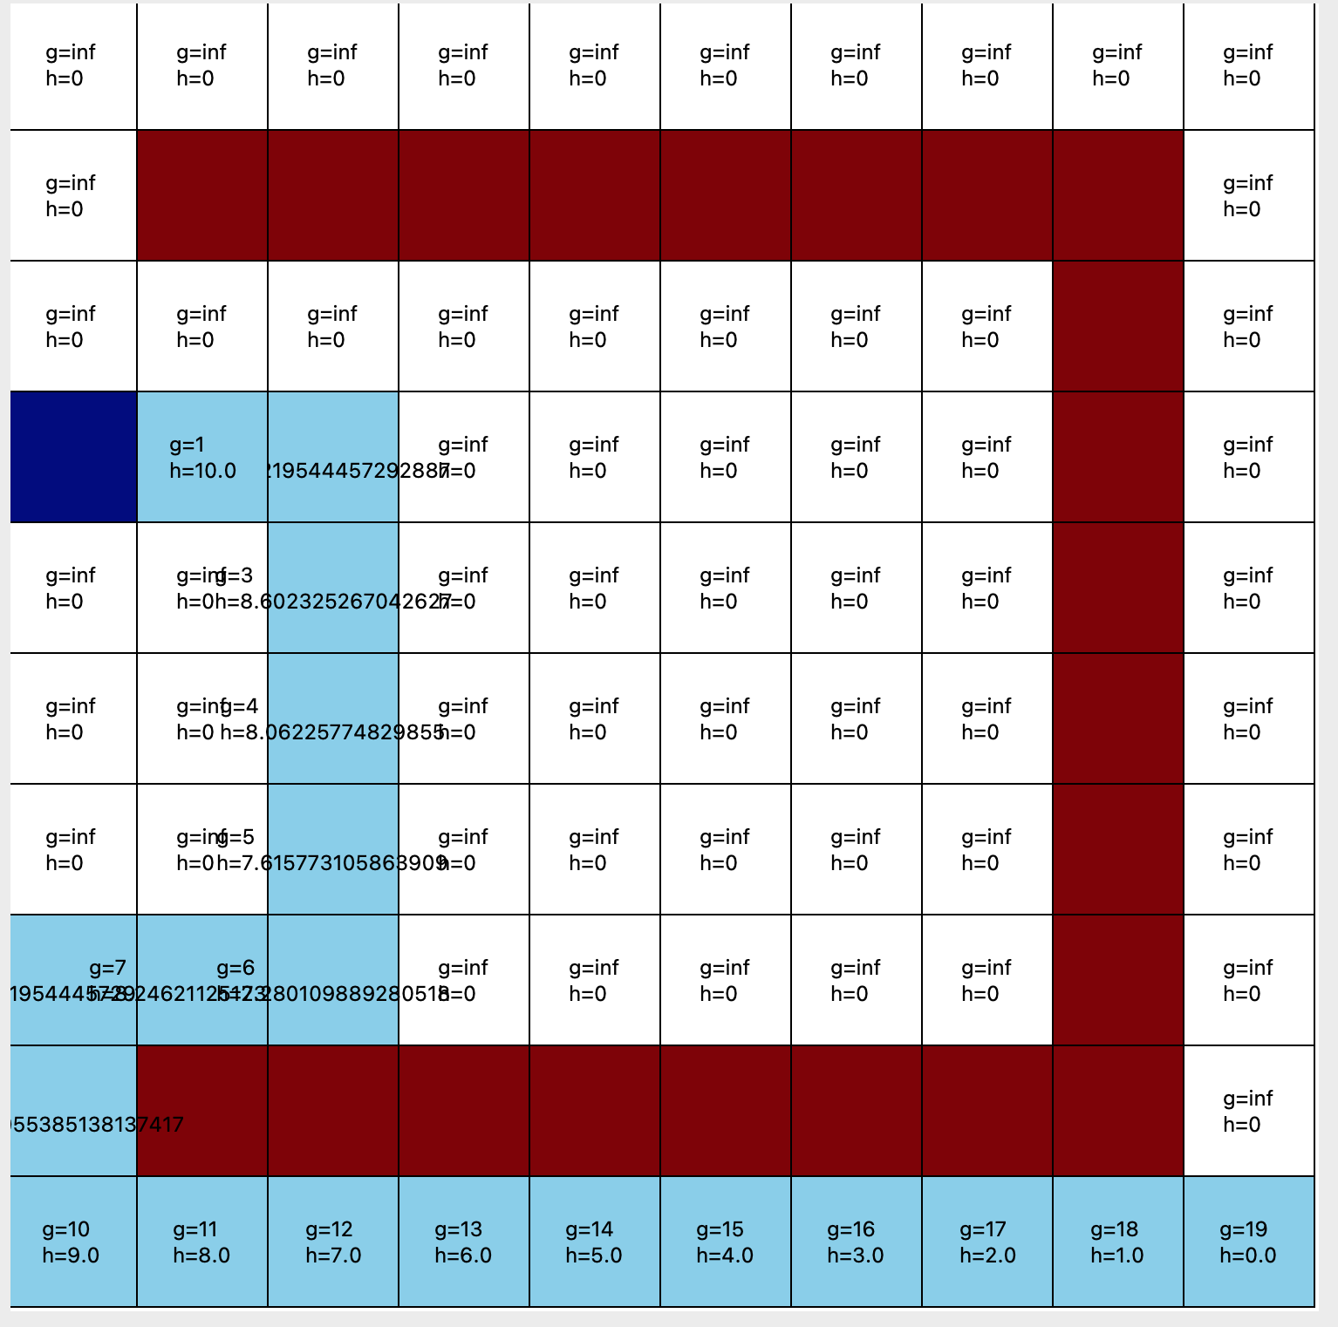

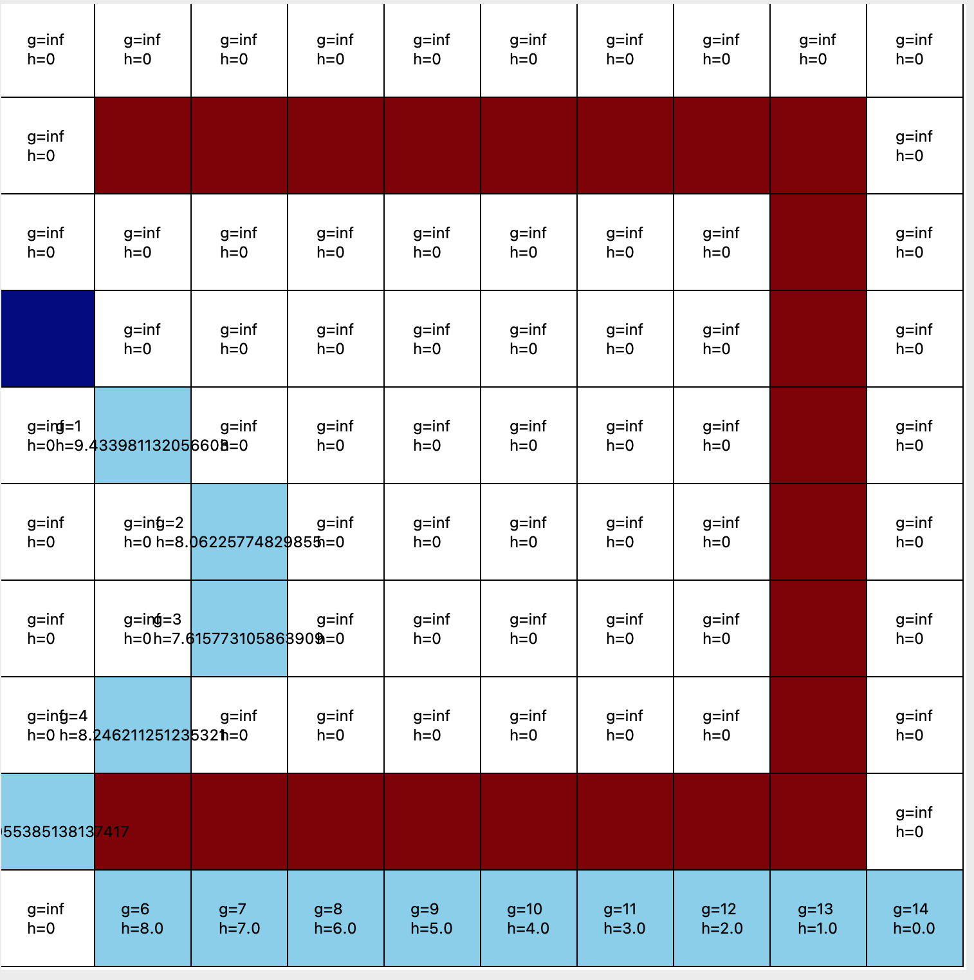

**Problem 3**

In this problem we will evaluate the effects of adding weights to our actual cost and out heuristic:

| alpha | beta | observation |
| --- | --- | --- |
| 2 | 2 | Path did not change |
| 2 | 3 | Path did not change |
| 3 | 2 | Path did not change |

In this section we will evaluate the bias towards the states that are closer to the goal. Meaning we will adjust the weight of our heuristic keeping the weight of our actual cost constant:

*Beta = 2*

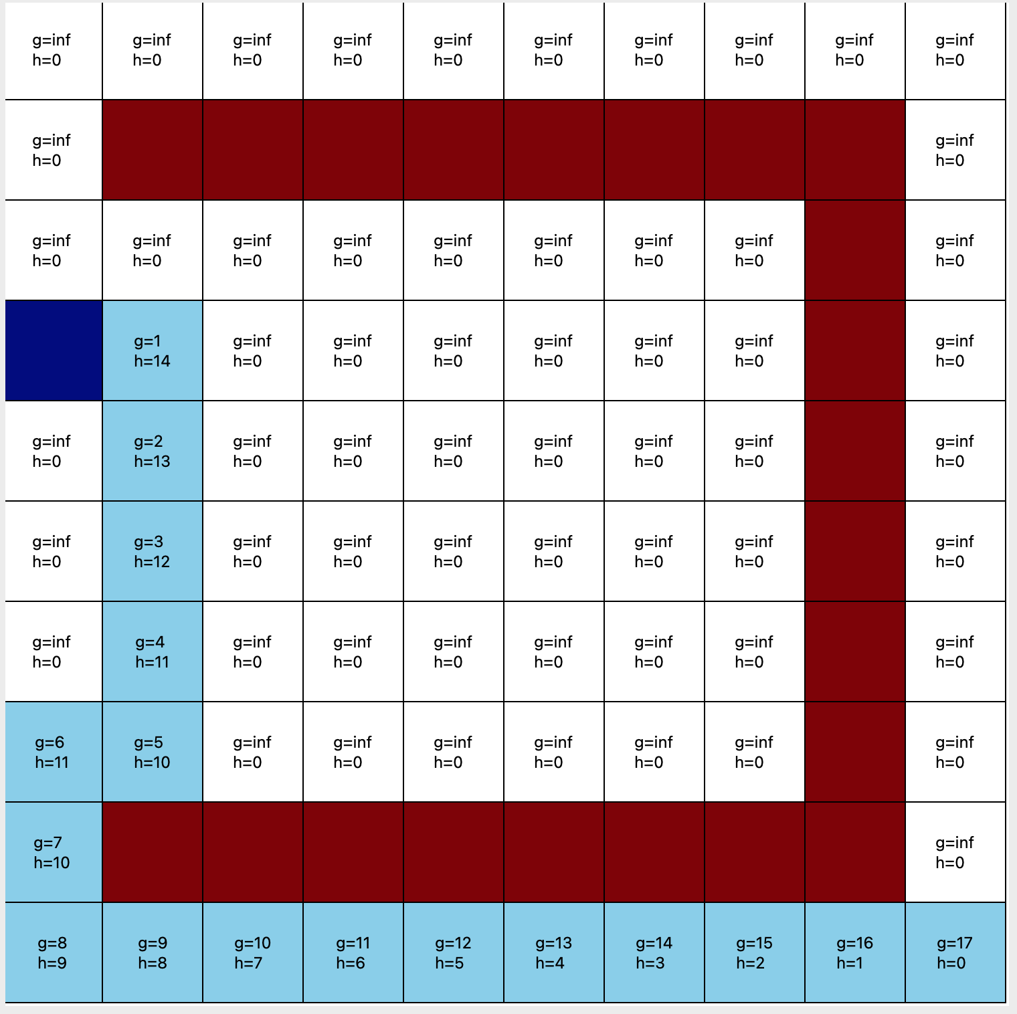

*Beta = 3*

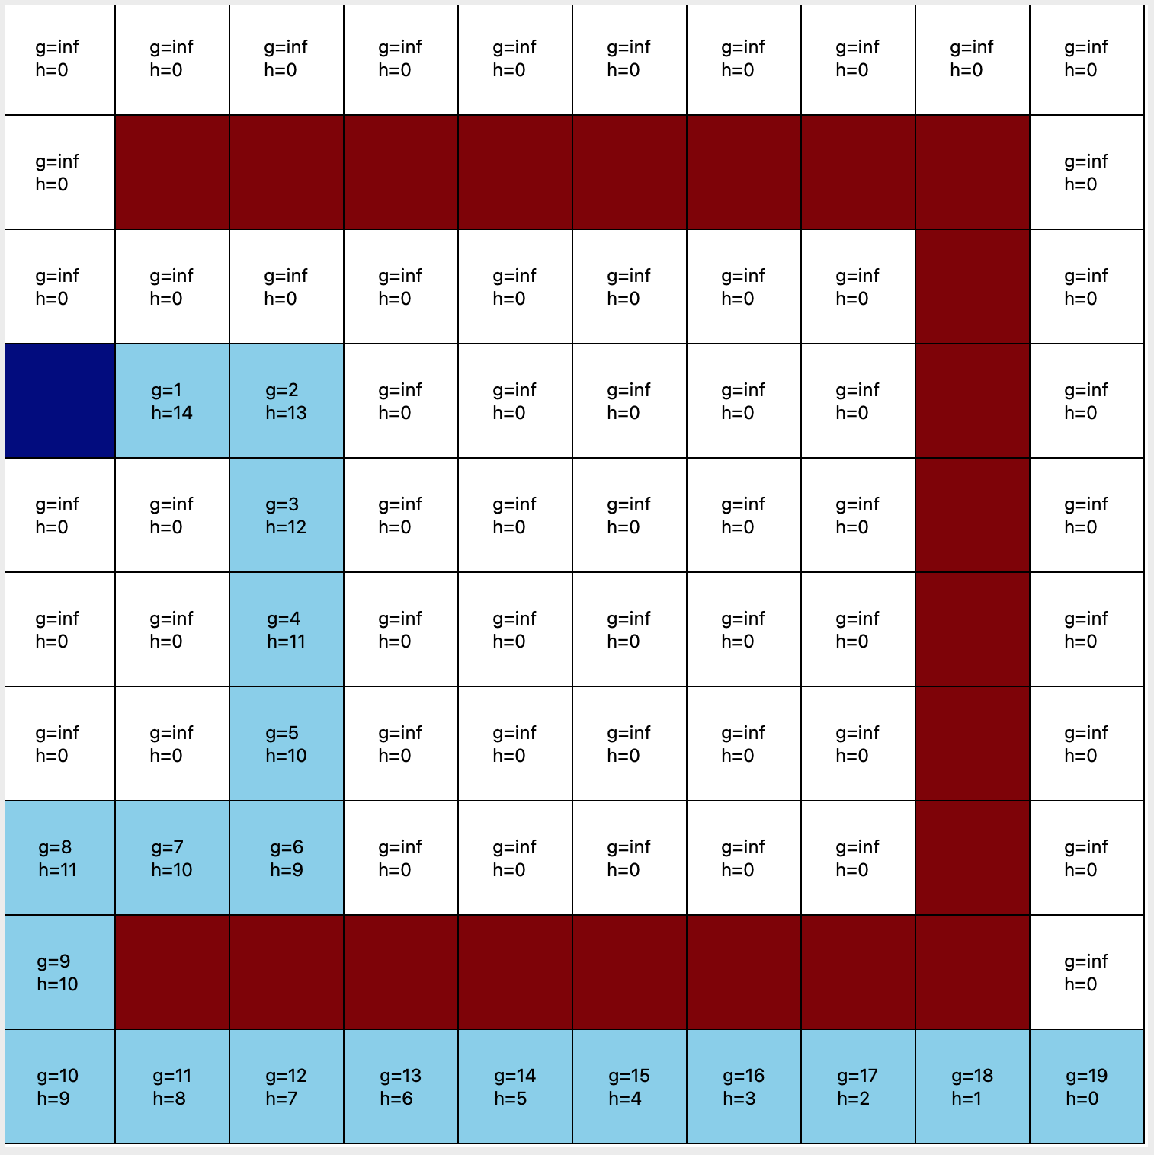

*Beta = 4*

